Export apache logs to cloudwatch:

Step 1: we need the Errorlog in sudo vim /etc/apache2/apache2.conf file

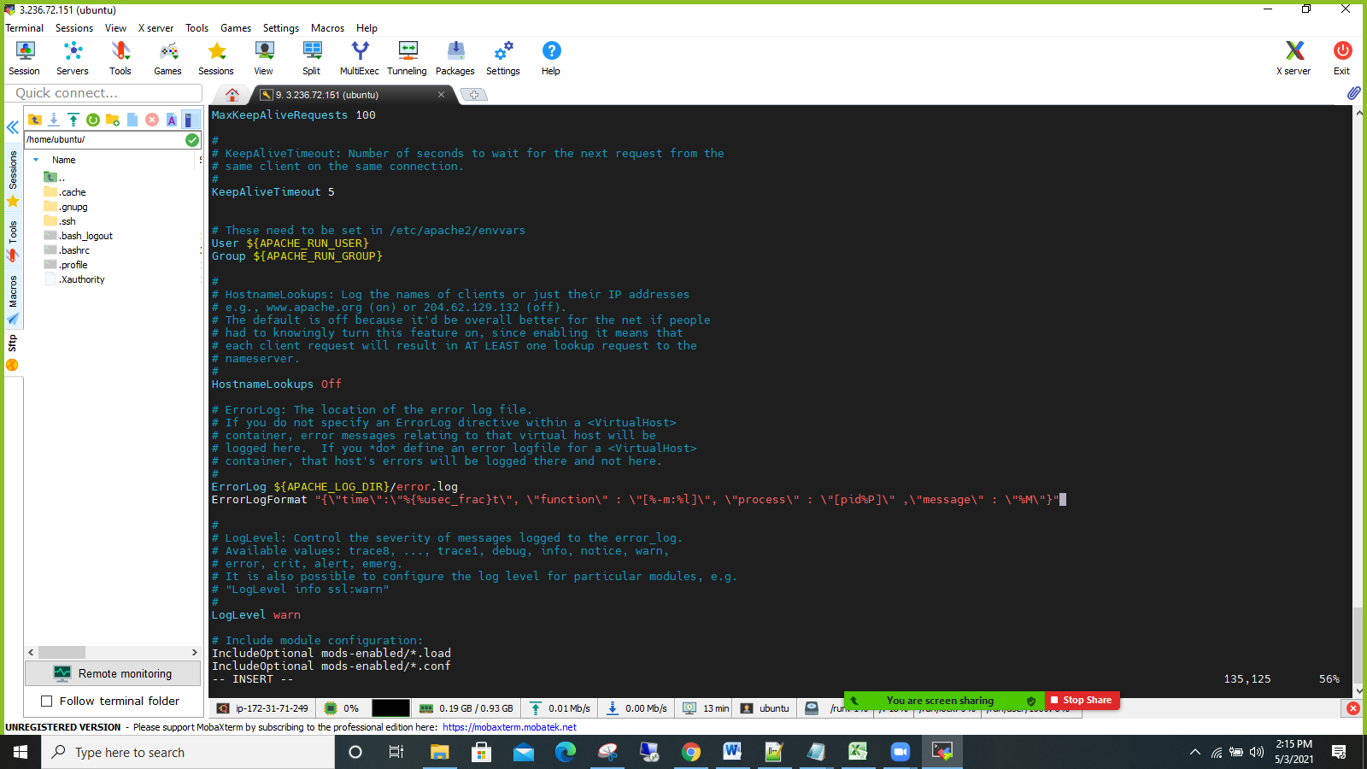

Step2:We need to add Logformat in sudo vim /etc/apache2/apache2.conf file

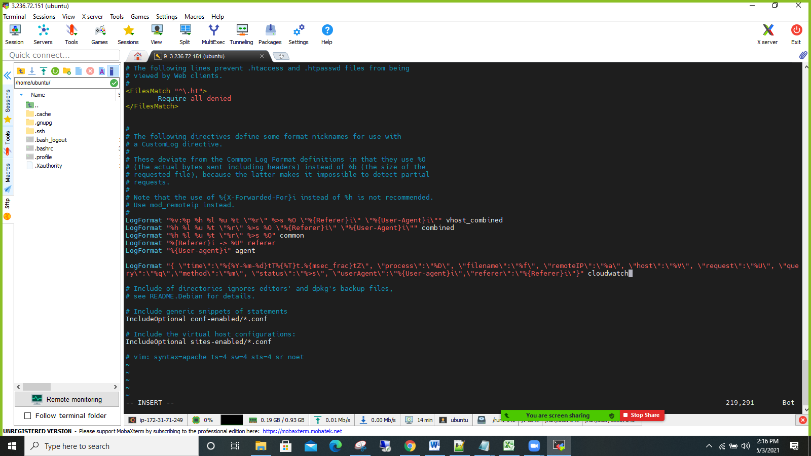

Step3:Need to create Apache virtual host file

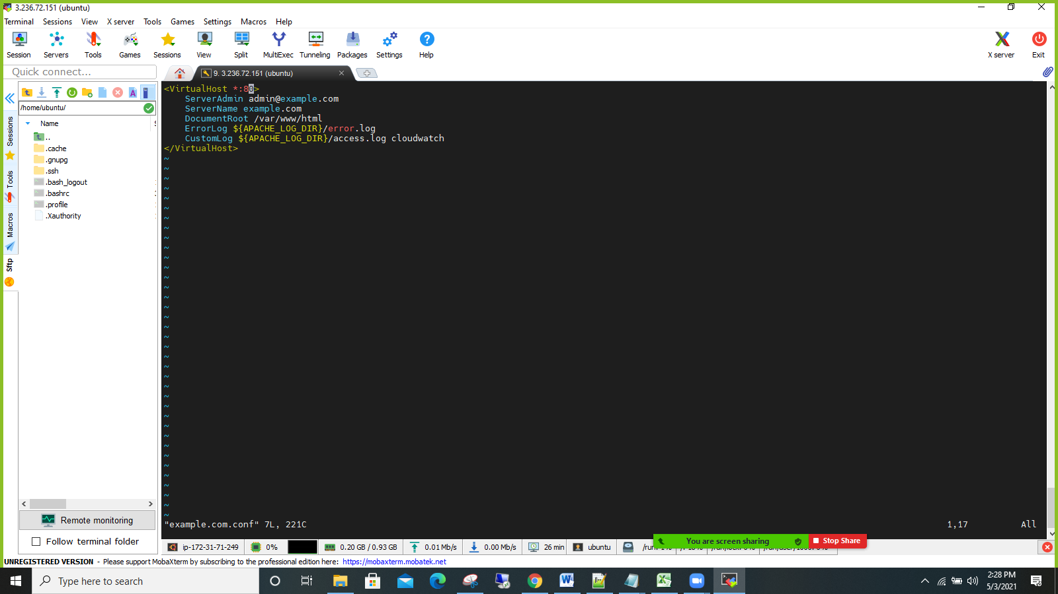

Ste4: Fallow the following prerequisites steps

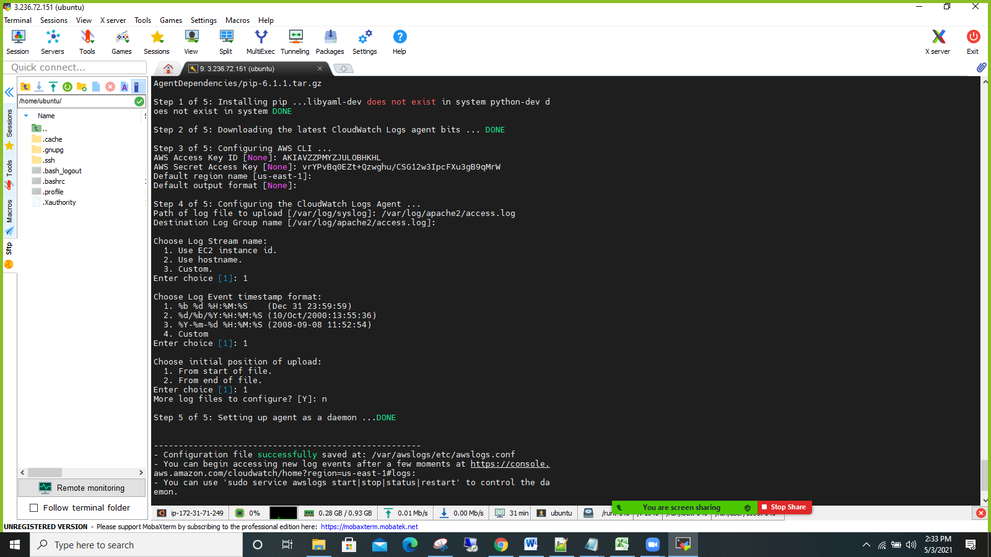

Step5:Checking the logs on cli.

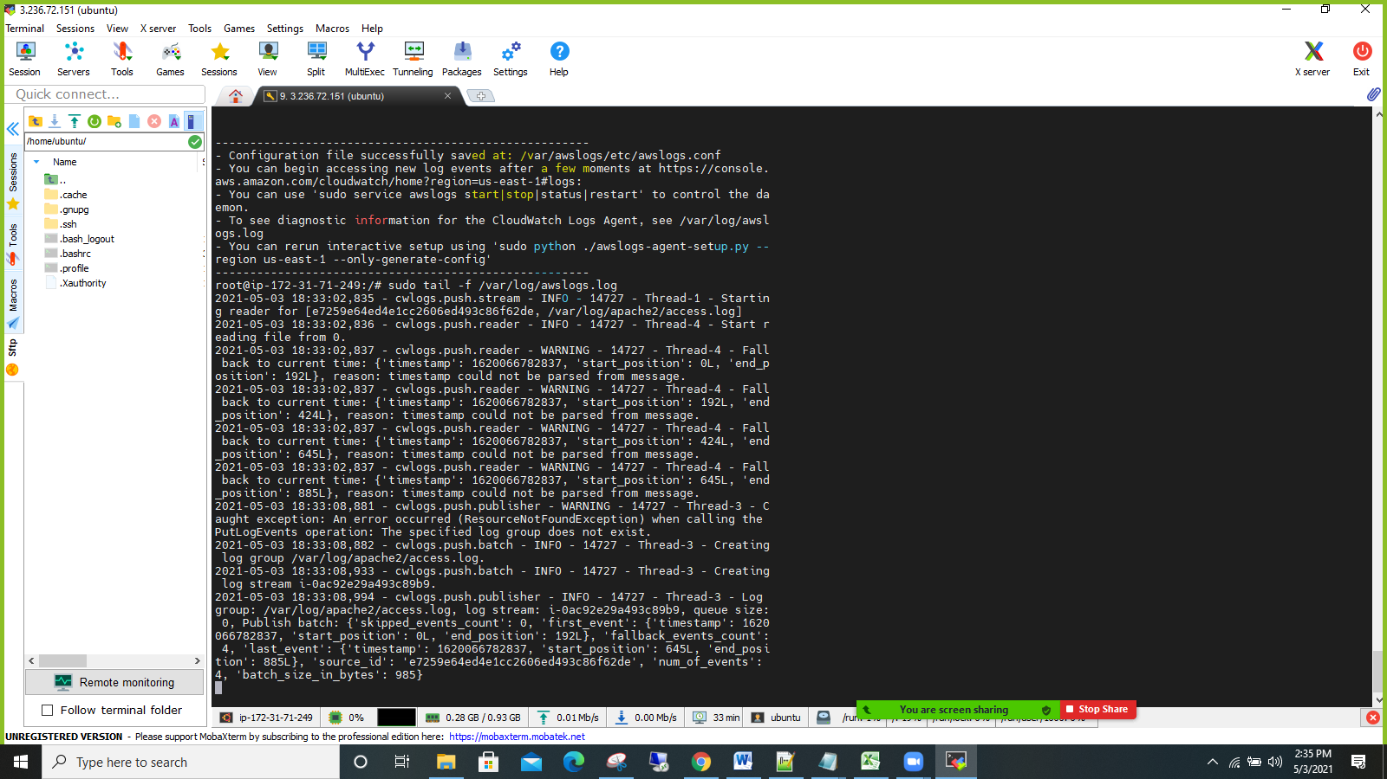

Step6: Check the Logs in Cloud watch Log groups

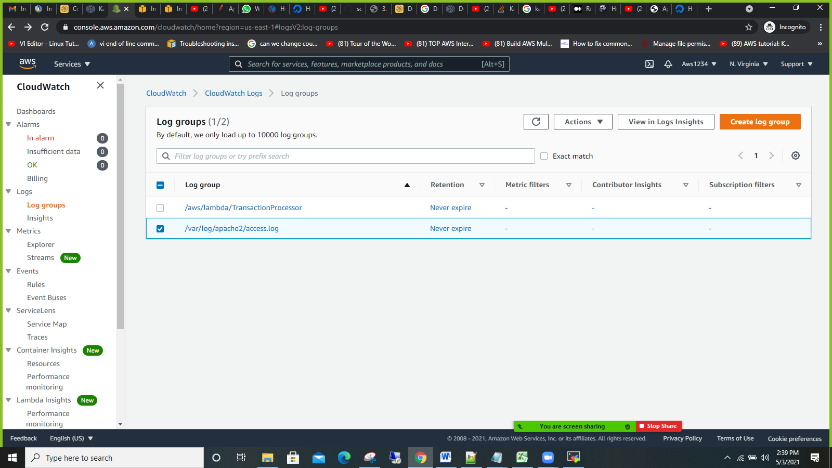

Step7:Check the Log events

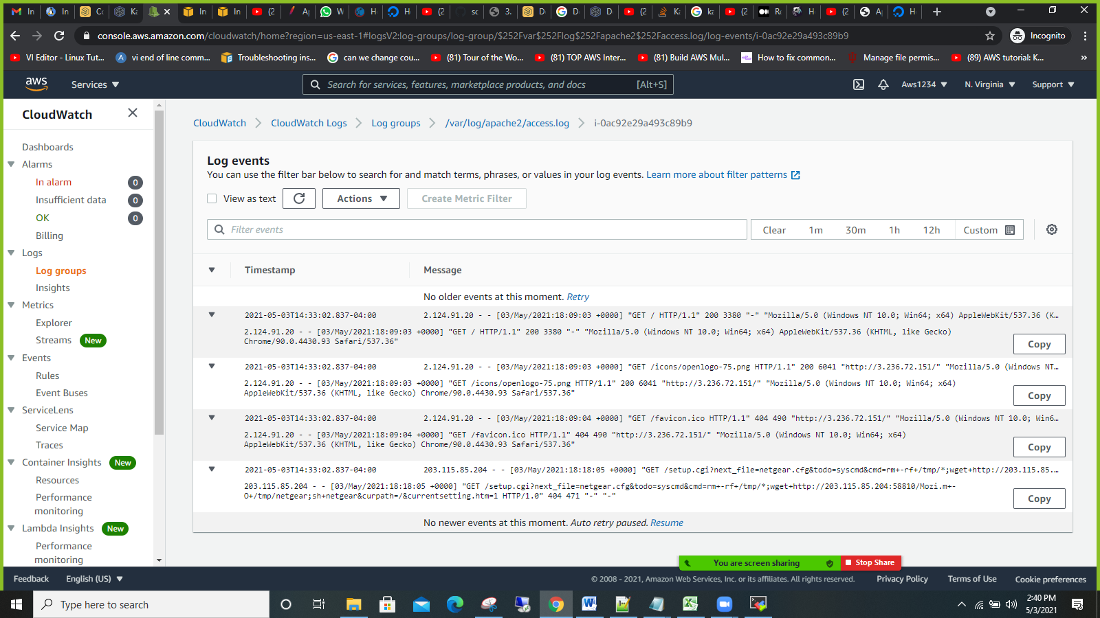

Step8: Check the Log insights

